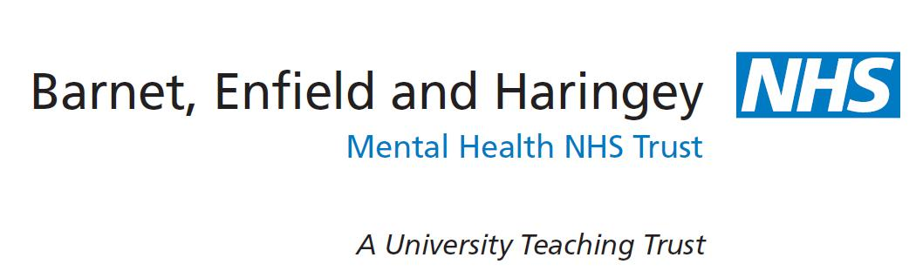

Annual General Meeting

Monday 24 October 2022

Online via Microsoft Teams

2pm Welcome
Pippa Aitken, Interim Chair

2.05pm CEO’s overview of the year
Jinjer Kandola MBE, Chief Executive

2.20pm Quality overview of the year
Amanda Pithouse, Chief Nursing Officer

2.30pm Financial overview of the year
David Wragg, Chief Financial Officer

2.40pm Our Recovery Strategy
Clare Scott, Interim Director of Nursing
Tania Charles, Expert by Experience
Hannah Czapnik, Expert by Experience

2.50pm Questions

3.15pm Closing remarks
Pippa Aitken, Interim Chair

