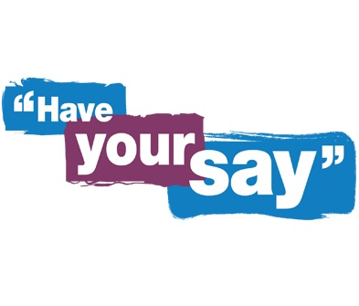
Barnet Forum for people using our services and their carers

Barnet Mental Health services want to hear what you have to say about our Adult Mental Health services
We are looking to hold a regular forum and need you to get involved to share your ideas for how you want the forum to be set up and topics you would like to be included!
What is a forum? Forums are informal meetings where service- users, carers and staff work together to improve mental health services. The forum will give you an opportunity to feedback your experiences and ideas.
How do I get involved? Please click the following link which will invite you into the scheduled meeting: Join Microsoft Teams Meeting Please note Microsoft Teams is the video conference platform used by the Trust to host virtual meetings.
Please contact Helen Price via email: helen.price25@nhs.net if you need to request the MS Teams link or need additional support to attend the virtual Service User and Carer Forum.

When is our first virtual forum taking place?
Date: Thursday 29 October 2020
Time: 1pm- 2pm
Venue: Microsoft Teams

