**Workforce Disability Equality Standard (“WDES”) Report 2021/22**

**Introduction**

The WDES is an annual set of measures for the NHS, designed to track how Trusts are ensuring their staff processes are fair and equitable for all. The evidence shows that people who are differently abled do not fare as well as their white counterparts, when it comes to employment, through the range of ‘touchpoints’ like recruitment, promotion, training opportunities etc.

This report shows how Barnet Enfield and Haringey Mental Health Trust (BEH) is doing in its disability equality aspirations, and an action plan for the next 12 months is at the end to help us work with staff to improve their experience and equitable outcomes.

Table 1: BEH ESR overarching disability information *at a glance*

|  |  |  |  |  |
| --- | --- | --- | --- | --- |
| Our workforce MyESR disability completion percentages are: | of which | Our workforce MyESR self-reported disability percentages are: | and | Our workforce MyESR self-reported no disability percentages are: |
| Clinical – **82.4%** (completion)  Non-Clinical – **78.62%** (completion)  Medical & Dental – **70.93%** (completion)  Overall completion rate in the workforce:  **80.98%** | Clinical – **4.7%**  Non-clinical – **4.5%**  Medical & Dental – **2.64%**  Overall self-reported disability in the workforce:  **4.55%** | Clinical – **77.7%**  Non-clinical – **74.2%**  Medical & Dental – **68.28%**  Overall self-reported no disability in the workforce:  **76.41%** |

**Contents**

Indicator 1 – workforce profile of disability status; clinical, non-clinical and medical & dental workforce 3

Our Submission 4

Summary 4

Indicator 2 – Relative likelihood of candidates who disclose no disability being appointed from shortlist 5

Our submission 5

Summary 5

Indicator 3 – relative likelihood of staff with disabilities entering the formal capability process, compared to staff with no disabilities 6

Our submission 6

Summary 7

Indicator 4a – Percentage of staff experiencing bullying, harassment or abuse from patients, relatives or the public in last 12 months 7

Our submission 7

Summary 8

Indicator 4b – Percentage of staff experiencing bullying, harassment or abuse from managers in the last 12 months 8

Our submission 8

Summary 9

Indicator 4c – Percentage of staff experiencing bullying, harassment or abuse from colleagues in the last 12 months 10

Our submission 10

Summary 11

Indicator 4d – Percentage of staff saying that the last time they experienced bullying, harassment or abuse at work, they or a colleague reported it, in last 12 months 11

Summary 12

Indicator 5 – percentage of staff who believe that BEH provides an equal opportunity for career progression or promotion 13

Our submission 13

Summary 13

Indicator 6 – percentage of staff saying they have felt pressure from their manager to come to work despite not feeling well enough to perform their duties 14

Our Submission 14

Summary 15

Indicator 7 – percentage of staff who say they are satisfied with the extent to which their organisation values their work 15

Our Submission 16

Summary 16

Indicator 8 – percentage of disabled staff who say that BEH has made adequate adjustment(s) that enable them to carry out their work 17

Our submission 17

Summary 17

Indicator 9 – Staff engagement scores from staff survey 17

Our Submission 17

Summary 18

Indicator 9b – has your organisation made arrangements so that the voice of disabled staff can be heard? 18

Our Submission 18

Indicator 10 – percentage of Trust Board Members by disability status compared with wider workforce 18

Our submission 19

Summary 19

Conclusion 20

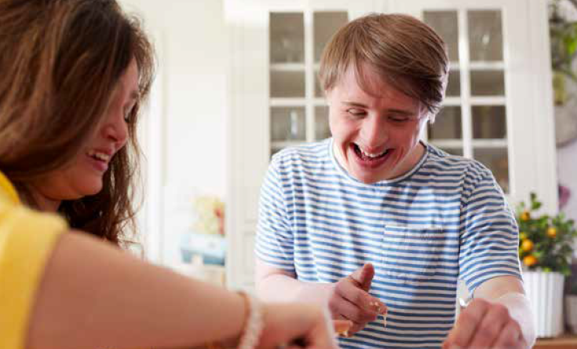

# ****Indicator 1 – workforce profile of disability status; clinical, non-clinical and medical & dental workforce****

**At 31.03.22, the Trust had a total of *n=*3,513 people (headcount) in its employment, comprising:**

* **People who disclose disabilities on MyESR *n=*160**
* **People who disclose no disabilities on MyESR *n=*2,689**
* **People with “disability status unknown” on MyESR *n=*670.**

**BEH’s WDES submission for non-medical staff is made in clusters, rather than bands:**

* **Cluster 1 – Agenda for Change pay bands 1-4**
* **Cluster 2 – Agenda for Change pay bands 5-7**
* **Cluster 3 – Agenda for Change pay bands 8a & 8b**
* **Cluster 4 – Agenda for Change bands 8c to Very Senior Manager grade (VSM).**

## **Our Submission**

**Table 2: Non-clinical staff 2021-22: Disability status**

|  |  |  |  |
| --- | --- | --- | --- |
|  | **Self-report disabled *n=*** | **Self-report not disabled *n=*** | **No self-report *of* disability *n=*** |
| Cluster 1 | 22 | 274 | 81 |
| Cluster 2 | 3 | 145 | 36 |
| Cluster 3 | 1 | 42 | 11 |
| Cluster 4 | 3 | 21 | 6 |
| **Total** | **29** | **482** | **134** |

**Table 3: Clinical staff 2021-22: Disability status**

|  |  |  |  |
| --- | --- | --- | --- |
|  | **Self-report disabled *n=*** | **Self-report not disabled *n=*** | **No self-report *of* disability *n=*** |
| Cluster 1 | 36 | 610 | 154 |
| Cluster 2 | 76 | 1133 | 250 |
| Cluster 3 | 12 | 257 | 49 |
| Cluster 4 | 0 | 48 | 6 |
| **Total** | **124** | **2048** | **459** |

**Table 4: Medical & Dental staff 2021-22: Disability status**

|  |  |  |  |
| --- | --- | --- | --- |
|  | **Self-report disabled *n=*** | **Self-report not disabled *n=*** | **No self-report *of* disability *n=*** |
| Consultant | 2 | 94 | 113 |
| Non-Consultant Career Grade | 1 | 25 | 44 |
| M&D Trainee Grades | 3 | 36 | 70 |
| **Total** | **6** | **155** | **227** |

**Table 5: overall workforce 2021-22: Disability status – headcount values and percentages**

|  |  |  |  |  |  |
| --- | --- | --- | --- | --- | --- |
| **Self-report disabled** | | **Self-report not disabled** | | **No self-report of disability** | |
| ***n*=** | **%** | ***n*=** | **%** | ***n*=** | **%** |
| **160** | **4.55%** | **2,689** | **76.41%** | **670** | **19.04%** |

## Summary

* With c.20% of the workforce not disclosing disability status on MyESR, work is indicated to encourage all staff to disclose their protected characteristics.
* Highest rates of non-completion of disability status on MyESR are with medical and dental staff groups, where there are only *n*=6 individuals who have shared that they have a disability.
* A usual data distribution of disability sees more disclosures of disabilities at lower bandings, and this is the case with BEH (with the non-clinical cluster 4 excepted).

# ****Indicator 2 – Relative likelihood of candidates who disclose no disability being appointed from shortlist****

**In the year to 31.03.2022, Trust appointing managers interviewed a total of 2,809 candidates for employment, and subsequently appointed 747 candidates – meaning BEH appointed 26.6% of all candidates interviewed.**

## **Our submission**

* **Non-disabled candidates are 0.86 times more likely to be appointed than candidates who disclose disability.**

**Table 6: Recruitment data for shortlist to appointment 2021-22**

|  |  |  |  |  |
| --- | --- | --- | --- | --- |
| **Disability status** | **Actual numbers of candidates interviewed *n=*** | **Percentage of candidates who were subsequently employed** | | **Actual numbers of candidates who were subsequently employed *n=*** |
| **This year** | **Relative to last year** |
| **Disabled candidates** | **205** | **28.8%** |  | **59** |
| **Non-disabled candidates** | **2,471** | **24.8%** |  | **614** |
| **Candidates with disability not disclosed** | **133** | **55.6%** |  | **74** |
| **Relative likelihood of the appointment of candidates who disclose no disability** | | | | **0.86** |

**BEH’s appointment relative likelihood figure is largely unchanged from last year (0.89). However, less people are disclosing disability, and numbers of candidates preferring ‘not to complete’ have more than doubled. The reason for this is unknown but it hasn’t impacted the overall likelihood this year.**

**There is a differential experience of 4 positive percentage points for those who disclose a disability, in current year. This is likely to have been driven – at least, partly – by the Trust’s membership of Disability Confident; scheme that guarantees people with disabilities an interview as long as they meet essential criteria for the role.**

## **Summary**

* **This indicator forms a substantive part of the overall EDI Strategy action plan, to increase people with disabilities in the BEH workforce.**
* Campaign planned for Q3 2022/23 to increase disclosures of disability on MyESR for staff at all pay bands – with newly recruited employees a focus of this work in their induction period.
* **There is room in 2022-23 to standardise the Trust’s employee value proposition (EVP) for disabled applicants, to include a positive statement about valuing everybody as unique individuals. At present, no consistent approach in terms of positive action statements in Trust job adverts for disabled people is identifiable. However, the evidence base shows that people with diverse ability, culture or identity need a more personalised approach to persuade them to apply for a role with a new employer. This approach will further support the Trust’s recruitment and retention work.**

# ****Indicator 3 – relative likelihood of staff with disabilities entering the formal capability process, compared to staff with no disabilities****

**In the two years to 31.03.2022 (current year), *n=*15 staff members overall have been formally subject to the Trust’s capability policy for access to more intense management that remediates poor performance. Numbers are small (0.43% of the workforce overall) and thereby able to inflate the ratio by the addition of only *n=*1.**

## **Our submission**

* BEH Staff with disabilities are 16.81 times more likely to enter the formal capability process than their non-disabled counterparts.

This data was not collected last year, and NHSEI colleagues are suggesting that a two-year average is more informative than one-year values. **Therefore, in the two-year period to reporting date, *n=*1 person with disabilities in the BEH workforce has undergone a capability process.**

## **Summary**

Although the likelihood ratio appears high for this indicator, it relates to one person over 2 years, and is for reasons unrelated to their health or disability. The ratio is therefore likely to fluctuate wildly over the next few years because of small numbers and is nearly impossible to meaningfully identify trend.

# ****Indicator 4a – Percentage of staff experiencing bullying, harassment or abuse from patients, relatives or the public in last 12 months****

This indicator is drawn from staff survey results and is disaggregated by disability status to show the differential treatment by the public of our staff. Simply put, it is a proxy indicator for disability abuse from the public. It also demonstrates an assumption from some members of the public that people who are differently abled are an ‘easy target’ upon which to take out their irritation, anger or stress when using or visiting our services.

## **Our submission**

* 39% of staff with disabilities have told us they’ve experienced bullying from patients, members of the public and visitors in the last 12 months.
* 30.5% of staff with no disabilities have told us they’ve experienced bullying from patients, members of the public and visitors in the last 12 months; **a differential of 8.5 percentage points.**

T**able 7: experience of bullying, harassment and abuse from public last 12 months 2021-22**

|  |  |  |  |  |  |  |
| --- | --- | --- | --- | --- | --- | --- |
|  | 2018 | 2019 | 2020 | 2021 | Current trend | **Differen-tial 2020/21** |
| BEH staff with disabilities | 42.8 | 42.9 | 34.5 | 39 |  | **8.5%** |
| BEH staff with no disabilities | 34.4 | 35 | 31.3 | 30.5 |  |
| Benchmark staff with disabilities | 35.4 | 35 | 31.8 | 32.2 |  | **7.5%** |
| Benchmark staff with no disabilities | 26.5 | 27 | 24.7 | 24.7 |  |

*Figure 4: Staff experience of bullying from patients, relatives & public in last 12 months (2021)*

## **Summary**

* 333 BEH staff with disabilities and 1,333 BEH staff with no disabilities responded to this question, meaning that
  + *n*=130 staff experienced bullying from patients and public
  + *n*= 203 staff did not experience bullying from patients and public.
* In 2020, our staff with disabilities had reduced incidence of bullying, harassment and abuse from people coming into our services, and this is likely to have been because of reduced face to face patient contact appointments.
* Work is indicated to explore best practice interventions in relation to this indicator. The Equality Diversity & Inclusion team is well placed to lend expertise in this work and to ensure the voice of minority groups informs Trust actions.

# ****Indicator 4b – Percentage of staff experiencing bullying, harassment or abuse from managers in the last 12 months****

This indicator is drawn from staff survey results and is disaggregated by disability status to show the differential treatment by managers. It is a proxy indicator for ableism from those who hold decision-making positions for teams. It also shows workforce attitudes – both covert and overt, and conscious and unconscious – of how each of us actively includes (or otherwise) people who may look, mobilise or communicate differently.

## **Our submission**

* Staff with disabilities at BEH have told us that 19.3% of them have experienced bullying, harassment or abuse from a manager.
* Staff with no disabilities have told us that 10.7% of them have experienced bullying, harassment or abuse from a manager; **a differential of 8.6 percentage points.**

**Table 8: experience of bullying, harassment and abuse from managers last 12 month 2021-22**

|  |  |  |  |  |  |  |
| --- | --- | --- | --- | --- | --- | --- |
|  | 2018 | 2019 | 2020 | 2021 | Current trend | **Differen-tial 2020/21** |
| BEH staff with disabilities | 22.6 | 24.7 | 24.9 | 19.3 |  | **8.6%** |
| BEH staff with no disabilities | 14.2 | 12.8 | 14.7 | 10.7 |  |
| Benchmark staff with disabilities | 17.6 | 16.8 | 15.2 | 13.4 |  | **6.3%** |
| Benchmark staff with no disabilities | 9.4 | 9.4 | 8.5 | 7.1 |  |

*Figure 5: Staff experience of bullying from managers last 12 months (2021)*

Overall experiences in manager behaviour to colleagues for both disabled and non-disabled staff has improved over the WDES period. Improvements this year have been more significant for those with disabilities.

## **Summary**

* 331 staff with disabilities and 1,312 staff with no disabilities responded to this question, meaning that
  + *n=*64 staff with disabilities experienced bullying from a manager
  + *n=2*67 staff with disabilities did not experience bullying from a manager.
* Staff experience of bullying harassment and abuse from a manager is improving for both disabled and non-disabled groups, and the differential gap is closing.
* Work is due to take place in 2022-23 to support managers in understanding disability and how to make adequate adjustments for staff who are differently abled, under the main EDI Strategy action plan.

# ****Indicator 4c – Percentage of staff experiencing bullying, harassment or abuse from colleagues in the last 12 months****

This indicator is drawn from staff survey results and is disaggregated by disability status to show the differential treatment by colleagues on staff. It is a proxy indicator for intra-team ableism. It also shows workforce attitudes – both covert and overt, and conscious and unconscious – of how each of us actively includes (or otherwise) people who may look, mobilise or communicate differently.

## **Our submission**

* BEH Staff with disabilities have told us that 22.5% of them have experienced inappropriate behaviour from other staff members.
* BEH Staff with no disabilities have told us that 16% of them have experienced inappropriate behaviour from other staff members; **a differential of 6.5 percentage points.**

**Table 9: experience of bullying, harassment and abuse from colleagues last 12 months 2021-22**

|  |  |  |  |  |  |  |
| --- | --- | --- | --- | --- | --- | --- |
|  | 2018 | 2019 | 2020 | 2021 | Current trend | **Differen-tial 2020-21** |
| BEH staff with disabilities | 32.3 | 33.3 | 27.7 | 22.5 |  | **6.5** |
| BEH staff with no disabilities | 17.9 | 17.3 | 19.7 | 16 |  |
| Benchmark staff with disabilities | 23.3 | 22.8 | 21.3 | 20.2 |  | **7.9** |
| Benchmark staff with no disabilities | 14.2 | 13.9 | 13 | 12.3 |  |

Experiences in staff behaviour to colleagues for both disabled and non-disabled groups is improving over the 4-year WDES period.

*Figure 7: Staff experience of bullying from colleagues in last 12 months (2021)*

## **Summary**

* 333 staff with disabilities and 1,315 staff with no disabilities responded to this question, meaning that
  + *n=*80 staff with disabilities experienced bullying from colleagues
  + *n=*253 staff with disabilities did not experience bullying from colleagues.
* Staff experience of bullying harassment and abuse from colleagues is going in the right direction.
* The experience of disabled staff being bullied by colleagues has improved by nearly 10 percentage points over the life of the WDES.
* Health Education England funded equality diversity and inclusion training sessions are due to be rolled out Q2-Q4 2022-23 for all front-line nursing, psychological therapy, social work and allied health professional staff. This is anticipated to kick start a new phase of the Trust’s Inclusion Programme, whereby cultural work will challenge ableist views in the workforce.

# ****Indicator 4d – Percentage of staff saying that the last time they experienced bullying, harassment or abuse at work, they or a colleague reported it, in last 12 months****

**This indicator is of interest to BEH management as it conveys the confidence staff members have in the Trust’s processes and managers to understand, investigate and rectify inappropriate behaviour if and when it happens.**

* **BEH staff with disabilities told us that 60.2% of them reported bullying, harassment or abuse at work when it happened (or a colleague did it on their behalf)**
* **BEH staff with no disabilities told us that 66.1% of them reported bullying, harassment or abuse at work when it happened (or a colleague did it on their behalf); a differential of 5.9 percentage points.**

**Table 10: experience of reporting bullying, harassment and abuse last 12 months 2021-22**

|  |  |  |  |  |  |  |
| --- | --- | --- | --- | --- | --- | --- |
|  | 2018 | 2019 | 2020 | 2021 | Current trend | **Differen-tial 2020-21** |
| BEH staff with disabilities | 59.1 | 50 | 46.2 | 60.2 |  | **5.9** |
| BEH staff with no disabilities | 55.5 | 51.6 | 58.3 | 66.1 |  |
| Benchmark staff with disabilities | 55.9 | 57.4 | 58.8 | 59.4 |  | **1.6** |
| Benchmark staff with no disabilities | 57.3 | 59.3 | 60.8 | 61 |  |

*Figure 7: staff reports of bullying, harassment and abuse 2021-22*

## Summary

* 171 staff with disabilities and 490 staff with no disabilities responded to this question, meaning that
  + 103 staff with disabilities reported bullying when it happened
  + 68 staff with disabilities did not report bullying when it happened.
* Confidence to report inappropriate behaviour in BEH staff – both with disabilities and no disabilities – is higher than benchmark average and trend is improving.
* Confidence to report in BEH staff with disabilities has jumped this year, with a 14 percentage point increase, which brings it into line with benchmark. An increase of nearly 8 percentage points has also been seen in the non-disabled workforce.
* This data may be reflective of the externally commissioned Freedom to Speak Up service.

# ****Indicator 5 – percentage of staff who believe that BEH provides an equal opportunity for career progression or promotion****

This indicator is a ‘perception’ question; the inference is that not only does the Trust need to be carrying out equality interventions, but it needs to be visible in doing so. Visibility increases the confidence of staff with protected characteristics to apply for training and promotion as it becomes available.

## **Our submission**

* 44.6% of staff with disabilities at BEH hold the belief that the Trust will offer them fair, equitable career progression opportunities and promotion
* 50.2% of staff with no disabilities hold the belief that the Trust will offer them fair, equitable career progression opportunities and promotion; **a differential of 5.6** **percentage points.**

**Table 11: staff belief they will be offered equal opportunity for career progression and promotion 2021-22**

|  |  |  |  |  |  |  |
| --- | --- | --- | --- | --- | --- | --- |
|  | **2018** | **2019** | **2020** | **2021** | **Current trend** | **Differen-tial 2020-21** |
| BEH staff with disabilities | 41.6 | 34.2 | 41.5 | 44.6 |  | **5.6** |
| BEH staff with no disabilities | 48.4 | 46.5 | 48.5 | 50.2 |  |
| Benchmark staff with disabilities | 50.7 | 52.5 | 54.3 | 54.4 |  | **5.8** |
| Benchmark staff with no disabilities | 58.1 | 58.3 | 60 | 60.2 |  |

*Figure 8: staff perception of equal opportunities for progression and promotion 2021-22*

## **Summary**

* 345 BEH staff with disabilities, and 1,391 staff with no disabilities, responded to this question, meaning that
  + *n=*154 staff with disabilities feel they will have equality of access to opportunities for progression and promotion
  + *n=* 191 staff with disabilities do not feel they will have equality of access to opportunities for progression and promotion.
* The year-on-year trend is good in terms of eroding the differential, which has gone from 6.8 percentage points to 5.6 percentage points over the life of the WDES.

# ****Indicator 6 – percentage of staff saying they have felt pressure from their manager to come to work despite not feeling well enough to perform their duties****

This indicator measures ‘presenteeism’ which is the phenomena of staff attending work, but unable to contribute well or at all during their shift. This indicator conveys a sense of how people with disabilities feel they are received by the organisation when managing their health by staying away from work to recover from an episode of ill health or a flare-up.

## Our Submission

* **25.2% of BEH staff with disabilities say they have felt pressure from their manager to come to work when not well enough to perform their duties.**
* **18.5% of BEH staff with no disabilities say they have felt pressure from their manager to come to work when not well enough to perform their duties; a differential of 6.7 percentage points.**

**Table 12: staff saying they have felt pressure from their manager to come to work despite not feeling well enough to perform their duties 2021-22**

|  |  |  |  |  |  |  |
| --- | --- | --- | --- | --- | --- | --- |
|  | **2018** | **2019** | **2020** | **2021** | **Current trend** | **Differen-tial 2020-21** |
| BEH staff with disabilities | 28.2 | 29.4 | 41.6 | 25.2 |  | **6.7** |
| BEH staff with no disabilities | 17.9 | 17.2 | 19.7 | 18.5 |  |
| Benchmark staff with disabilities | 26.2 | 23.9 | 24.1 | 20.8 |  | **6.1** |
| Benchmark staff with no disabilities | 16.4 | 14.5 | 16.6 | 14.7 |  |

*Figure 9: staff reporting pressure from manager to come to work when not well enough to perform their duties 2021-22*

## Summary

* 234 BEH staff with disabilities and 666 BEH staff with no disabilities responded to this question, meaning that
  + *n=*59 staff with disabilities felt pressure from manager to come to work when not fit to do so
  + *n=*175 staff with disabilities do not experience feelings of pressure from manager to come to work when not fit to do so.
* The trend for all staff – both disabled and non-disabled – is going in the right direction.
* There was a peak in 2020’s staff survey for staff with disabilities, and this is likely explained by the COVID-19 emergency ways of working, as managers were under pressure to staff wards and teams in circumstances of high absence and clinical shielding. This is not to say that presenteeism ultimately benefits an employer in any way.
* The Trust’s scores for both staff with disabilities and staff with none are higher than benchmark, with differential scores indicating that BEH staff with disabilities are bearing the brunt of this pressure to come to work when poorly.
* This year’s EDI Strategy plans for consideration of a disability leave policy equivalent to that at C&I, whereby people with disabilities can absent themselves from the workplace for a limited time every year, without fear of triggering the Trust’s formal absence process. This is for use if they need to attend health or social care appointments or if they need to recover from an episode of ill health or a flare-up. A return to work that is too quick often results in further absences for rest and recuperation, impacting both employee self-confidence and manager ability to plan work.

# ****Indicator 7 – percentage of staff who say they are satisfied with the extent to which their organisation values their work****

This indicator is important because feeling your work is meaningful is a major contributor to resilience against stress.

## Our Submission

* 43.1% of BEH staff with disabilities say they’re satisfied with the extent to which the organisation values their work
* 51.1% of BEH staff with no disabilities say they’re satisfied with the extent to which the organisation values their work; **a differential of 8 percentage points.**

**Table 13: staff saying they are satisfied with the extent to which the organisation values their work 2021-22**

|  |  |  |  |  |  |  |
| --- | --- | --- | --- | --- | --- | --- |
|  | **2018** | **2019** | **2020** | **2021** | **Current trend** | **Differen-tial 2020-21** |
| BEH staff with disabilities | 41.9 | 38.9 | 40.3 | 43.1 |  | **8.0** |
| BEH staff with no disabilities | 49.3 | 49.9 | 52.7 | 51.1 |  |
| Benchmark staff with disabilities | 38.5 | 41.6 | 44.6 | 43.6 |  | **7.9** |
| Benchmark staff with no disabilities | 50.2 | 52.9 | 55.2 | 51.5 |  |

*Figure 10: percentage of staff who are satisfied with the extent to which the Trust values their work*

## Summary

* 348 BEH staff with disabilities and 1,398 staff with no disabilities responded to this question, meaning that
  + *n=*150 staff with disabilities feel their contribution is valuable to BEH
  + *n=*198 staff with disabilities do not feel their contribution is valuable to BEH.
* Staff with no disabilities are more likely to feel confident that the Trust values what they do than those with disabilities.
* Staff with disabilities are less confident that their contribution is valued albeit that their satisfaction is in line with benchmark.
* The differential gap at BEH is closing and is now in line with benchmark differential.

# ****Indicator 8 – percentage of disabled staff who say that BEH has made adequate adjustment(s) that enable them to carry out their work****

The Equality Act 2010 makes failure to make reasonable adjustments for people with disabilities an offence. The Trust has a duty to make adjustments for people who are differently abled, in order that they can ‘play to their strengths’ at work and perform in the role. These adjustments may be a combination of environmental, sensory, communication or technological and involve physical equipment or flexible ways of working.

## Our submission

* 65.9% of BEH staff with disabilities say BEH has made adequate adjustments to enable them to carry out their work.

**Table 14: staff with disabilities who have had adequate adjustments made 2021-22**

|  |  |  |  |  |  |
| --- | --- | --- | --- | --- | --- |
|  | **2018** | **2019** | **2020** | **2021** | **Current trend** |
| BEH staff with disabilities | 72.2 | 71.5 | 73.2 | 65.9 |  |
| Benchmark staff with no disabilities | 77.3 | 76.9 | 81.4 | 78.8 |  |

## Summary

* Over the life of the WDES, the rate of those who have said they’ve had adjustments to carry out their role has been steady at c.72% but has dropped to 65.9% this year.
* Work to understand this year’s drop, and to rectify locally, is indicated for 2022-23.

# Indicator 9 – Staff engagement scores from staff survey

This indicator is a composite sore of how engaged a staff member is as determined by staff survey responses, disaggregated by disability status.

## Our Submission

* Engagement score for BEH staff with disabilities: 6.7
* Engagement score for BEH staff with no disabilities: 7.2
* Engagement score BEH average: 7.1

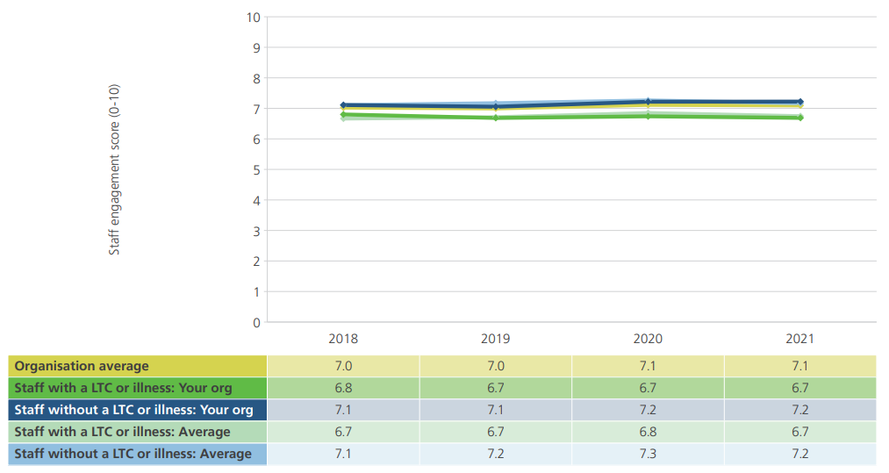

*Figure 11: engagement scores for BEH staff disaggregated by disability status 2021-22*

## Summary

* 349 BEH staff with disabilities, and 1,406 with no disabilities, responded to this question.
* BEH engagement scores for those with a disability and those with no disability are the same as respective benchmark scores.

# Indicator 9b – has your organisation made arrangements so that the voice of disabled staff can be heard?

## Our Submission

**Yes**: The Trust resources a staff equality network for disability. The Chair of the network is a passionate advocate for people with disabilities and takes an active part in the Trust’s Just and Inclusive pre-action panel, as well as disability working groups, designed to make things better for disabled people in BEH employment.

# ****Indicator 10 – percentage of Trust Board Members by disability status compared with wider workforce****

This indicator is important to NHSEI because it clearly defines how representative the most senior levels of decision-making in the Trust are of the staff working in it. Historically, as well as across England currently, Trust Boards are not representative of their workforces in terms of being differently abled. This implies Trusts are not currently harnessing the benefits of diversity in terms of innovative, creative and sustainable strategic steering and decision-making. Patients, members of the public and staff alike have increasing expectations that decisions in NHS health services are made by people who look and talk like them – the WRES helps Trusts respond to this expectation.

## **Our submission**

Table 14: Board membership disaggregated by disability status 2021-22

|  |  |  |  |
| --- | --- | --- | --- |
|  | **Board Membership – with disabilities**  ***n*=** | **Board Membership – no disabilities *n*=** | **Board Membership – disability status not known *n*=** |
| Total Board Members * | 1 | 10 | 7 |
| *of which:*  Executive Board Members *  Non-Executive Board Members * | 0  1 | 7  3 | 1  6 |
| Staff in overall workforce | 160 | 2,689 | 670 |
| Board Membership disparity  By Executive Board Members  By Voting Board Members  By overall Board | -5%  1%  1% | 11%  -21%  -21% | -7%  20%  20% |

* All Board Members at BEH are counted as ‘voting members’

* At BEH, 5.56% of our overall Board has self-reported disability.
  + 10% of our non-executive team has self-reported disability
  + 0 of our executive team has self-reported disability.
* The impact of harmonising BEH executive team with Camden and Islington NHS FT on WRES indicators will be apparent in next year’s submission.
* The Trust is now well positioned to use assertive outreach methods to diversify candidate pools for any future open recruitment opportunities to vacant VSM roles. This can be achieved by EDI business partnering support from the Joint Head of EDI role.

## **Summary**

Out of the 19 individuals on BEH Board, one person in a non-executive role has self-reported a disability. This means that, overall, the Board is representative of the workforce in terms of being differently abled. When disaggregated for executive and non-executive, disabled people are not proportionately represented in the Executive team.

# Conclusion

There are 160 staff in the BEH workforce who disclose they have a disability in a personally identifying way (MyESR). The anonymous disclosures in the staff survey show us that the figure is actually many times this. Many of these staff members need adequate workplace adjustments in order to do their job in a way that does not aggravate existing health conditions or disabilities. There are times when staff reach out and share with the Equality Diversity and Inclusion team, or indeed their union representative, that these adequate adjustments have not been put in place, or have taken several years to implement – by which time, often, they decide to move on to another employer. The risk is then that they bring an external challenge, via Employment Tribunal as the lack of adequately adjusted working environment has been toxic to their health and wellbeing, and they leave angry, frustrated and feeling discriminated against. Colloquially, good will on the part of line managers is rarely the problem; rather Trust processes and policies need to be refreshed and made more readily accessible to those responsible for making adjustments for people in their teams. Further, roles and remits in terms of implementing adequate adjustments remain undefined. Actions taken this year will include the agreement of easy-to-follow processes and flow charts for managers and specialist stakeholders to the reasonable adjustments process (e.g. procurement, H&S, Occupational Health, finance, estates, IT) to expedite assistive equipment and other adjustments for people who need this support at work.

It is also recognised that a cultural shift towards the inclusion of people who are differently abled is needed. Being differently abled includes people who are neurodivergent, people whose cognition is different-not-less, as well as people who have a physical, mental or sensory impairment. This cultural shift can be achieved under the leadership of the Executive team with expertise from the Equality Diversity & Inclusion team, to step up organisational commitment to adequately adjusting work environments for people with disabilities. The EDI team is now fully resourced and well positioned to translate the data into quantifiable actions throughout the divisions, with the return on investment predicted in improved staff survey and WDES outcomes.

Next steps:

* Upload to centre of BEH WRES data – 31 August 2022
* Action plan (draft attached) which has been co-produced with BEH Disability staff equality network must be published – 31 October 2022

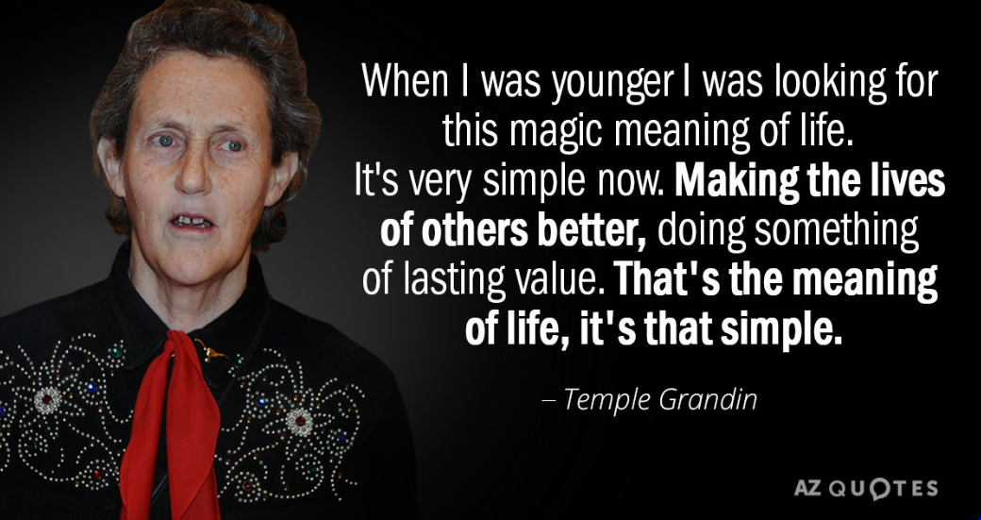

*Temple Grandin, author of Different Not Less, and Thinking in Pictures*

# Appendix 1 – Action Plan for ratification

(attached)